# CS 255 System Design Document Template

This template lays out all the different sections that you need to complete for Project Two. Each section has guidance to prompt your thinking. You will need to continually reference the interview transcript as you work to make sure that you are addressing your client’s needs. There is no required length for the final document. Instead the goal is to complete each section based on what your client’s needs are. Remove this note when you are finished, and replace all bracketed text with the relevant information.

## UML Diagrams

### UML Use Case Diagram

### UML Activity Diagrams

### UML Sequence Diagram

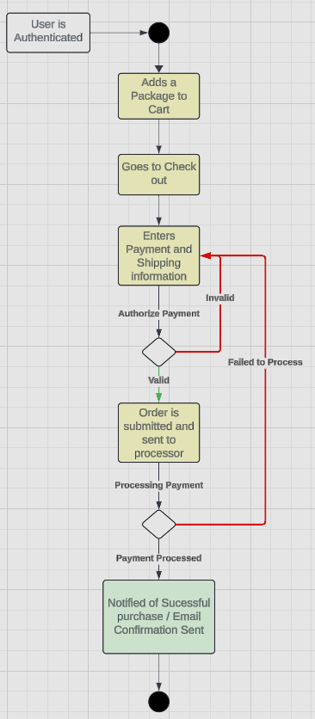

### UML Class Diagram

## Technical Requirements

*Due to the nature of the systems, there is a variety of different requirements needed to be met. Such as*

*Software:*

* Including and implementation of a web server for the website to run on.
* Utilization of a windows server in order to bring  stability.
* An SQL Server to maintain the database.
* Integrating backup software to preserve files and the database for the site.
* Implementation and integration of security software to prevent malicious attacks.

*Hardware*

* A reliable internet connection.
* An amount of storage for database data that can hold all necessary information.
* Computer or mobile phone to access website.
* A dedicated server for the website and it's data.
* Firewall to protect devices from malicious threats and attacks.